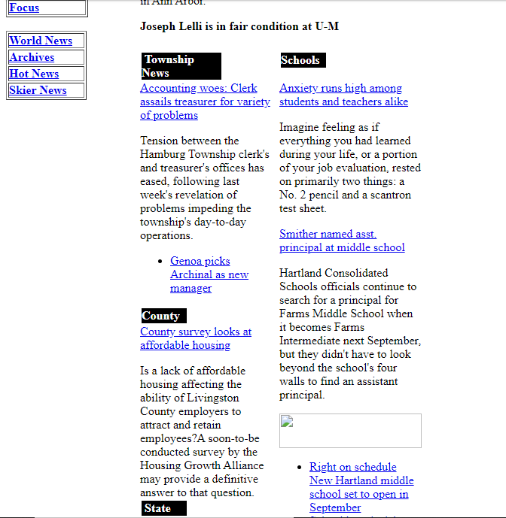

My first job after graduating from Central Michigan University was with an Internet Service Provider called HomeTown Online. The ISP was a subsidiary of the company which owned two local newspapers, HomeTown Newspapers. Our offices were located in the same building as the newsroom for the Livingston County Press, in Howell Michigan.

As a fresh college graduate with a journalism degree, I was totally thrilled to be working just a few doors down from an actual newsroom. It’s true that my job had very little to do with news reporting, but that didn’t dissuade me. I thought I would be there for a long time.

I feel as though I contributed some great new ideas to the company. When I began meeting with clients to discuss their website needs, I developed a standardized form which was designed to streamline the process of gathering information and developing a plan for their online presence. I restructured the design of the Livingston County Press and Brighton Argus website so that it looked a little more like an online publication. I also improved HomeTown Online’s marketing by designing newspaper display ads and produced a booklet which we handed out during a home show in Howell.

One of the biggest ways that I wanted to contribute was by helping the news staff think of innovative ways of packaging their news stories. At the time, the newspaper content I was publishing on the newspaper’s website was nearly identical to the articles which appeared in the print edition. I felt as though there could be ways to leverage the advantages of web publishing and provide online readers with more photos, bar charts, or maybe links to videos. Of course, back then the news content was most likely viewed as a loss leader which attracted potential subscribers, so I am not sure how much effort HomeTown Newspapers would have wanted to put into developing extra material. But, had I been given the chance I think I would have been able to help guide the company into the Internet age, either as a web producer or a digital content strategist.

As a business, I know that the operation had its problems. But, I feel like we were always able to offer the best user support possible, and we were slowly preparing HomeTown Newspapers for the digital age. If it had been given the chance, the staff could have continued to innovate and accomplish some great things.

I gained a lot of experience in the business world during my short time with HomeTown Online. I deepened my knowledge of web development, graphic design, and user support. I was also able to take on roles such as news liaison, and client representative, even before anybody recognized that these were needed. I was also proud of the design work that I contributed. I still have a HTOnline mug with the logo on the front of it.